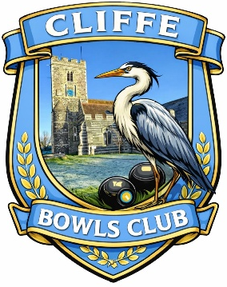

Cliffe Bowls Club is committed to providing a safe environment for young people and adults to enjoy playing bowls. In accordance with guidance issued by the Bowls Development Alliance we have systems in place to ensure activities at our club are an enjoyable and safe experience for all.
Everyone in bowls has a part to play in safeguarding young people and adults at risk.
In addition to our core safeguarding policies, we have other codes and guidelines in place to inform and guide our members & volunteers to embed good safeguarding practices throughout.
Cliffe Bowls Club believes everyone has the right to live free from abuse or neglect regardless of age, ability or disability, sex, race, religion, ethnic origin, sexual orientation, marital or gender status. We are committed to creating and maintaining a safe and positive environment and an open, listening culture where people feel able to share concerns without fear of retribution. Safeguarding is everybody’s responsibility.
Our Club Safeguarding Officer is Mick Kiernan, If you have any concerns, comments or feedback on any aspect of safeguarding please contact the safeguarding Officer.
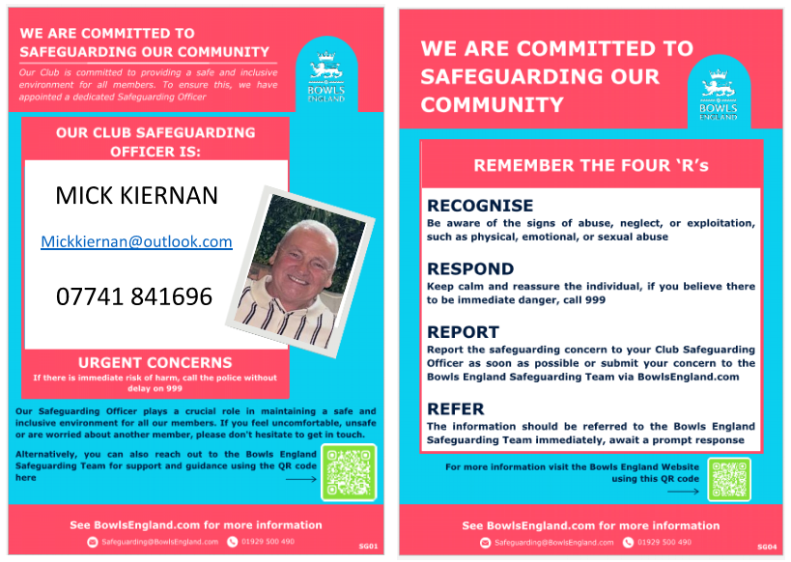
February 2026

